**DEPARTMENT OF COMPUTER SCIENCE AND ARTIFICIAL INTELLIGENCE**

**SUBJECT:** DBMS LAB ASSIGNMENT **Batch:** II CSE – 1

**Task 1:**

**Consider the following relations for an order processingdatabase**

CUSTOMER (cust_num: int,cname: string. gender:string)

**Syntax:** create table custm1238(cnum int,cname varchar(15),gender varchar(8), check(gender='male' or gender='female'));

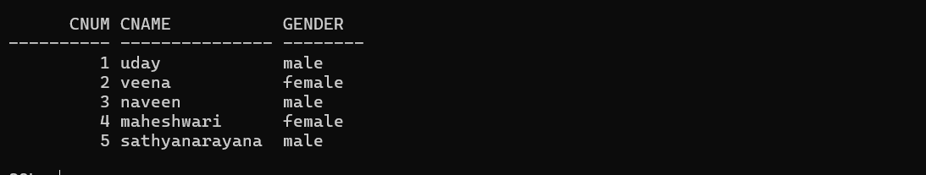

ORDER (order_num: int. odate: date. Cust_num: int, Ord_Amt: int)

**Syntax**: create table orde1238(onum int,odate date,cnum int,oamt int);

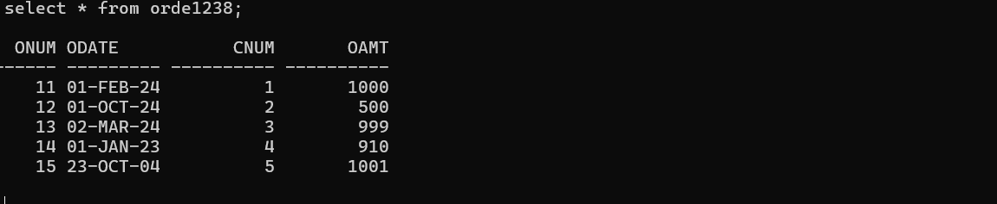

ORDER_ITEM (order_num: int, item_num: int. qty: int)

**Syntax:** create table item1238(item int,name varchar(15),price int);

ITEM (item_num: int,item_name: string,unit_price: int)

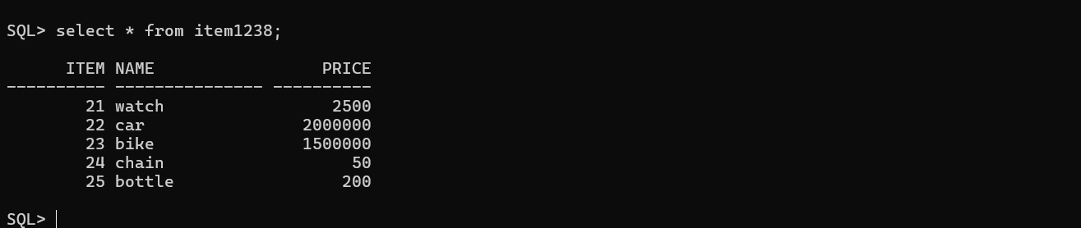

SHIPMENT (order_num: int. warehouse_num: int. ship_date: date) WAREHOUSE (warehouse_num: int. city: string)

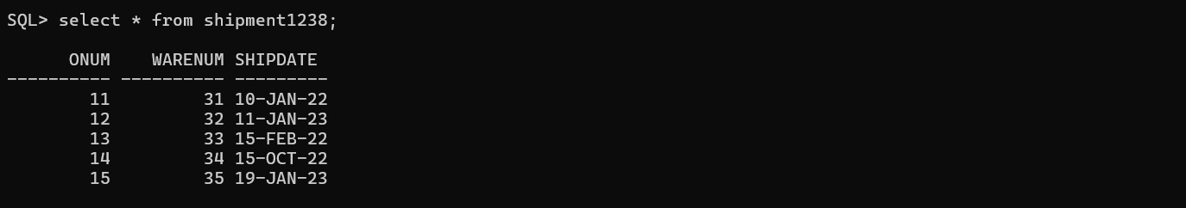

Create the above tables **WITHOUT** specifying the primary keys and foreign keys.

Enter at least five tuples for each relation and write SQL Queries for:

1. Display the list of items that are ordered by Sandeep

**Query:**

select i.name from item1238 i inner join ordit1238 o on o.item=i.item inner join orde1238 r on o.onum=r.onum inner join custm1238 c on c.cnum=r.cnum and c.cname='uday';

**Output:**



1. List the order number form orders that were shipped from any warehouses that the company has in a specific city.

**Syntax:**select s.onum from shipment1238 s inner join ware1238 w on s.warenum=w.warenum and w.city='nalgonda';

**Output:** 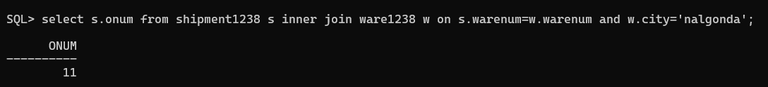

3.Delete an item from the ITEM table with order number = 12

**Syntax:**

delete item1238 where item in(select i.item from item1238 i inner join ordit1238 o on (o.item=i.item) where o.onum

**output:**



4. Update the price of all the items by15%.

**Syntax:**

update item1238 set price=price + price * 0.15;

**output:**

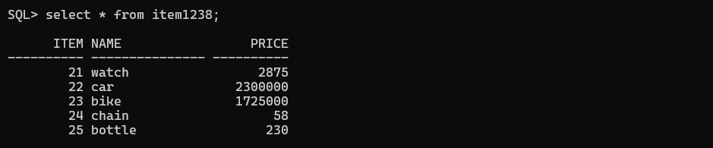

5. Display customer name, Items ordered by him along with Item-number, order- number

**Query:**

select * from item1238 i inner join ordit1238 o on o.item=i.item

**output:**

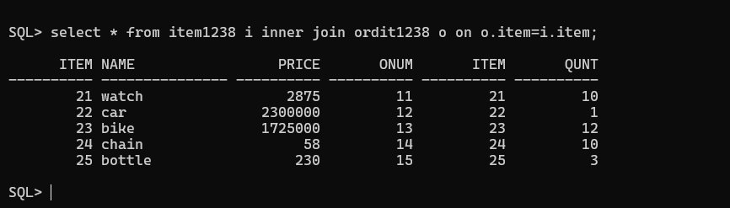

6. Display the names of the customers who have a shipment on 12/06/2021

**Syntax:**

select cname from custm1238 c inner join orde1238 o on o.cnum=c.cnum inner join shipment1238 s on s.onum=o.onum and s.shipdate='10-jan22';

**output:**



7. List the order number of the shipments that are happening from warehouse no-31

**Syntax:**

select onum from shipment1238 where warenum=31;

**output:**



8. List the names of the customers who ordered more than qty 10 of a particular item

**Syntax:**

select cname from custm1238 c inner join orde1238 o on o.cnum=c.cnum inner join ordit1238 r on r.onum=o.onum and r.qunt=10;

**output:**



9. Delete all the orders on 12/06/2021

**Syntax:**

delete orde1238 where odate='23-oct-2004';

**output:**

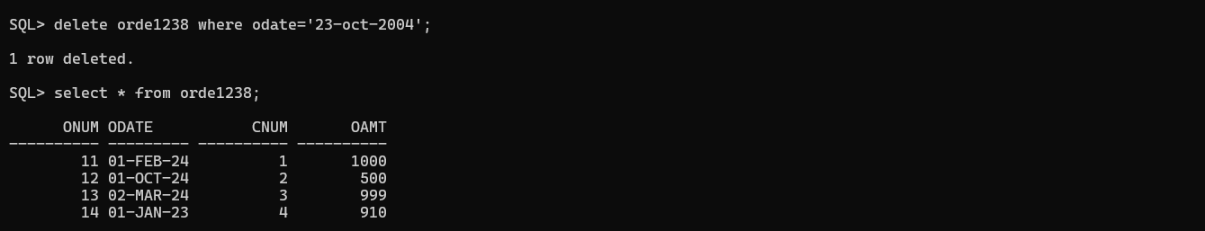

10. Update the order amount of a customer called sandy to 10000

**Syntax:**

UPDATE orde1238 o INNER JOIN custm1238 c ON c.cnum = o.cnum

SET o.oamt = 10000 WHERE c.cname = 'uday';

**Task-2:**

**Consider the following database for a banking enterprise**

**BRANCH** (branch-name:string, branch-city:string, assets:real)

create table branch1238(bname varchar(15),bcity varchar(15),assets real);

**output:**

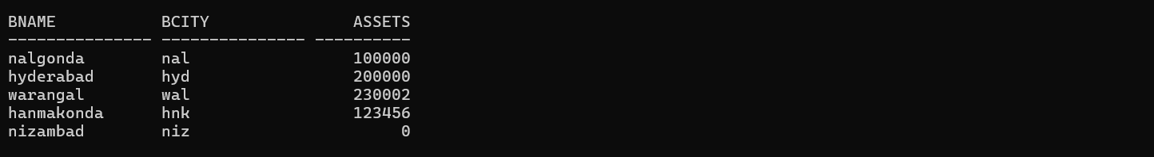

**ACCOUNT**(accno:int, branch-name:string, balance:real)

**output:**

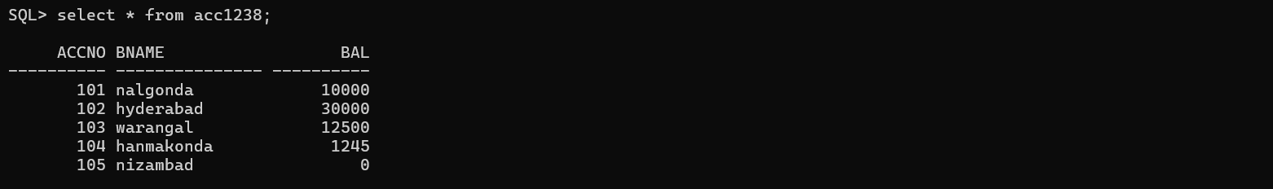

create table acc1238(accno int,bname varchar(15), bal real);

**DEPOSITOR**(customer-name:string, accno:int)

create table depost1238(cname varchar(15),accno int);

**output:**

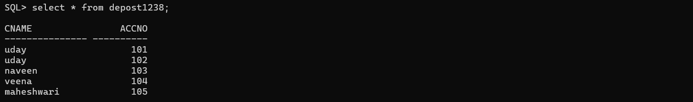

**CUSTOMER**(loan-number:int, branch-name:string, amount:real)

create table customer1238(loannum int,bname varchar(15),amount real);

**output:**

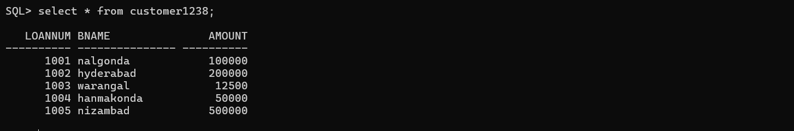

**BARROWER**(customer-name:string, loan-number:int)

create table barrow1238(cname varchar(15),loannum int);

**output:**

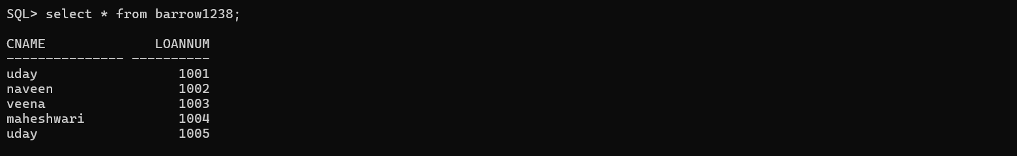

Create the above tables **WITHOUT** specifying the primary keys and foreign keys and enter at least five tuples for each relation

1. Find all the customers who have at least two accounts at the main branch

**Syntax:**

select cname from depost1238 group by cname having count(cname)>1;

**output:**

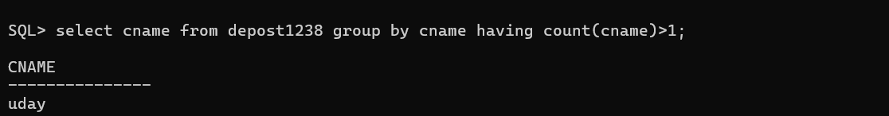

1. Find all the customers who have an account at all the branches located in a specific city

**Syntax:**

select accno from acc1238 a inner join branch1238 b on b.bname=a.bname and b.bcity='nal';

**output:**

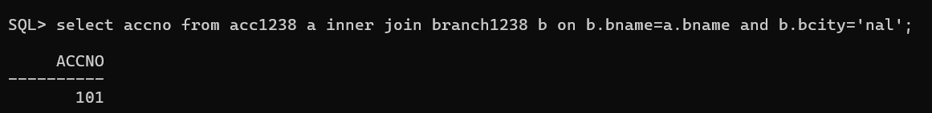

1. Display all the accounts in a specific branch along with Customer details.

**Syntax:**

select c.cname,c.accno from depost1238 c inner join acc1238 a on a.accno=c.accno and a.bname='nalgonda';

**output:**

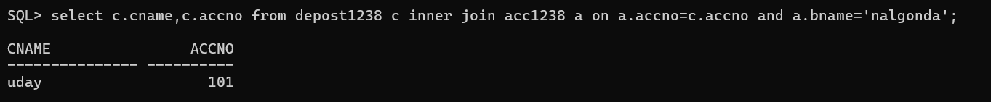

1. Display the loan details of a specific customer.

**Syntax:**

select c.loannum,c.bname,c.amount from customer1238 c inner join barrow1238 b on c.loannum=b.loannum and b.cname='uday';

**output:**

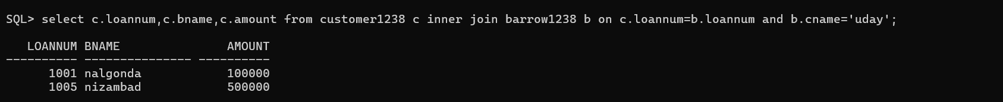

1. Display the names of the customers who borrowed a loan of minimum 10000

**Syntax:**

select cname from barrow1238 b inner join customer1238 c on c.loannum=b.loannum and c.amount>10000;

**output:**

